BOMBrowser

Table of Contents
1 Preface 2
2 Theory of operation 3
2.1 Revising a node 3
2.2 "Date from" / "date to" 4
2.3 BOM revisions 4
3 Browsing windows 7
3.1 Codes list window 7
3.1.1 Simple search 7
3.1.2 Edit menu 8
3.1.3 Search mode menu 9
3.1.4 Advanced search 9
3.2 Code context menu 10
3.3 Code properties panel 12
3.4 Shared windows menu 14
3.4.1 Windows menu 14
3.4.2 Help menu 14
3.4.3 File menu 15
3.5 Assembly window 16
3.5.1 File menu 17
3.5.2 Edit menu 17
3.5.3 View menu 17
3.5.4 Search menu 18
3.5.5 Export dialog 19
3.6 Where used window 20
3.7 Diff dialog 21
3.8 Special character for a search 24
3.9 Standard code properties 25
4 Editing window 25
4.1 Copy code dialog 25
4.2 Revise code dialog 27
4.3 Edit code dialog 28
4.3.1 Change of the children list 29
4.3.2 Change of the drawings 30
4.3.3 Change of the "date from" dates 31
4.3.4 Change the revision on which the dialog is operating 33
4.3.5 Menu edit 33
4.3.6 Menu import 34
5 Technical details 34
5.1 Configuration file 34
5.2 Database structure 35

Preface
BOMBrowser is tool to manage a technical BOM capable to describe a product from a technical point of view.
In the beginning BOMBrowser was developed only to navigate BOMs, then it was extended to edit a BOM also.
The navigation through the BOMs is both from top to bottom (see Show Assembly commands family) and from the bottom to the top (see Where Used commands family). The former set of commands are useful to understand how a product is composed. The latter set of commands are used to understand where a component is (or was) used. The results of these commands are indexed by dates.
From the BOMBrowser point of view a BOM is composed by an hierarchy of nodes linked to other nodes in a relationship parent child. To a node it is possible to attach a set of documents or links. Each node has some attributes like:
- description
- "date from" / "date to" date
- revision
- iteration
- ….
This attributes list may be extended changing the configuration file (see chapter 5.1 - Configuration file for further information).

Theory of operation
As stated before, a BOM is a hierarchy of nodes connected in a parent child relationship.
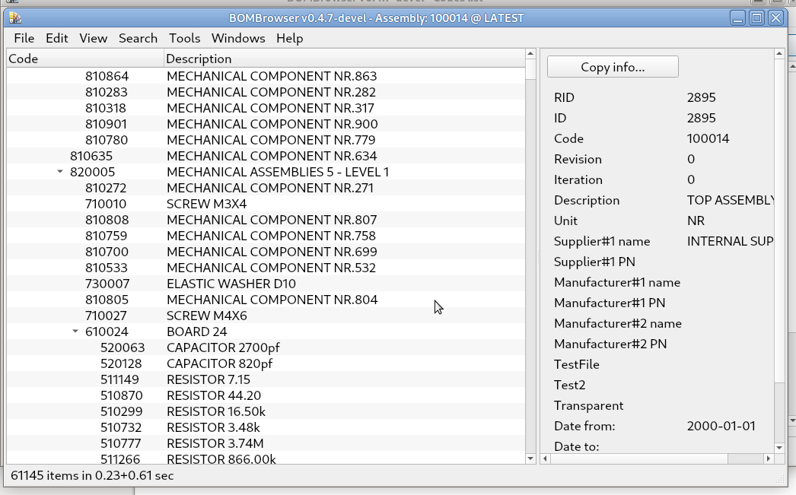
Each node has several attributes. The mains ones are:
- code
- description
- revision
- iteration
- "date from" / “date out” dates
- measure unit
- a list of children (the list may be empty)
- a list of attached documents/urls (the list may be empty)
Optionally, it is possible to configure further attributes attached to a node and/or to a child.
In a manufacturing process, a node of a BOM usually represent an assembly of its children or a purchase part. To a node is possible to attach documents (drawings, procedures, reports, technical specification) which describe the node (e.g. a drawing or a component specification) or the process that results in the node (e.g an assembling procedure).

Revising a node
To track the changes in the time, a node may be revised. A revision may consist in a change of any of the attributes of the node (like changing a description or a revision), or a change of one of its children or a change of the attached document. Some attributes are not changeable, like the code (fixed) and the iteration (managed by the system).
When a node is revised, its iteration attribute is increased. Usually the “revision” attribute is used to mark the revision index. However from the BOMBrowser point of view the revision is a simple text attached to the node. The sequence of the revision is unrelated to the value of the “revision” attribut; what matter are the date from date and the iteration.
It must be pointed out that the relation between the parent and the children is between the parent revision and the children code. The practical effect is that the revision of a node is not related to a specific BOM; if the user revise a node, all the BOMs see the new revision at the same time.
This models what happen in manufacturer processes, where each node represent a specific component that may be shared between different BOM. A change in a component will affect all the assemblies that use this specific component.

"Date from" / "date to"
Each revision of a node has a "date from" date and may have a "date to" date. These dates mark the validity of a specific revision. If multiple revisions of a node exist, the “date to” date is set to the day before of the “date from” date of the next revision. The last revision may not have “date to” date (e.g. it doesn’t have an end of the validity yet).
It is possible to change the “date from” date of a revision. However this implies a change of the “date to” date of the previous revision too.
An important rule about the "date from" / “date to” date and the assemblies is that the children must outlive the parent. So a child must have an initial "date from" date equal or lesser than the parent revision. And a child must have a final “date to” date equal or greater than the parent.
This means that you can mount an assembly (the parent) only if the components (the children) already exists.
It is important to point out, that a node revision refer to a children code. This means that the check is performed for each specific revision of the parent. But the parent date is checked only with the initial "date from" and final (if exists) "date to" of a child.

BOM revisions
A BOM may be composed by thousands nodes, each one may have several revisions and "date from" dates.
This means that for each "date from" of each node we may have different BOM. In fact a BOM is identified by a top level code and a date. And the nodes revisions considered are only the ones which have a compatible "date from" / "date to" with the date of the BOM that we are considering.
Example:
Node1: rev 0 (from 2020-01-10 to 2020-02-01), has the children: Node2, Node3, Node4
rev 1 (from 2020-02-02, no "date to"), has the children: Node2, Node3
Node2: rev 0 (from 2020-01-01 to 2020-01-15)
rev 1 (from 2020-01-16, no "date to")
Node3: rev 0 (from 2020-01-01 to 2020-02-12)
rev 1 (from 2020-02-13, no "date to")
Node4: rev 0 (from 2020-01-01, to 2020-02-01)

The nodes above have different revisions that create the following four possible BOM (the top code is always Node1, but the date are different).
Bom date validity | Tree
2020-01-10 … 2020-01-15 | Node1, rev0 | { | Node2, rev 0  Node3, rev 0  Node4, rev 0
2020-01-16 … 2020-02-01 | Node1, rev0 | { | Node2, rev 1  Node3, rev 0  Node4, rev 0
2020-02-02 … 2020-01-12 | Node1, rev1 | { | Node2, rev 1  Node3, rev 0
2020-02-13 ... | Node1, rev1 | { | Node2, rev 1  Node3, rev 1

Note that:
- Node4 has a "date to" prior to the "date to" of Node1. However Node4 is a children of Node1 rev 0 only. And the "date to" of Node1 rev 0 is not later than the "date to" of Node4.
- Node1 (the TOP node) has only 2 revisions (rev 0 and rev 1), however 4 different BOMs exist; this because the number of the BOMs are equal to the number of different "date from".
- each node is identified by a code and a revision. A BOM is identified by a code and a date.
- in the example from 2020-01-01 to 2020-01-15 the BOM is always the same.

Browsing windows
BOMBrowser born as tool to navigate the BOMs; only later it acquired the capability to edit/change the BOM. The typical workflow is: search a code, then find its assembly (Show assembly commands family) or its parents (Where used commands family).
During these navigation it is possible to edit any available code.

Codes list window
This is the first window that appear when the command is started. With this it is possible to search a code.

Simple search
This is the main window. It is used to do the simplest search between the codes list. It is possible to open in any time a new “Codes list” window pressing CTRL-L.
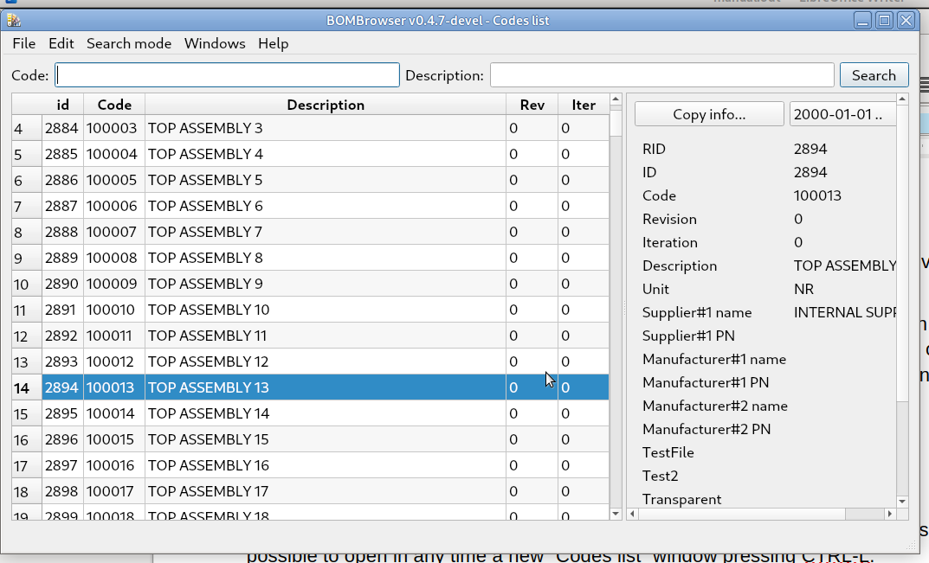
The most important part of the window is the left section where are listed the codes. For each code it is listed the Code, and the Description, Revision, Iteration (of the latest revision).

On the right there is the Code properties panel which shows the code properties and the attached documents or links (if any). See chapter 3.3 - Code properties panel for further information.
On the top part of the window there are the two input box for entering the Code and/or Description used to search the codes.
By default, the windows show the codes that satisfy both the fields. The match between these fields and the code happen when the (e.g.) Code field is a sub-string of the code listed.
It is possible to use special character for more powerful search. See chapter 3.8 - Special character for a search.

Edit menu
The edit menu, allows to copy the table values in the clipboard. The fields are TAB separated, and the rows are separated by a new lines character.
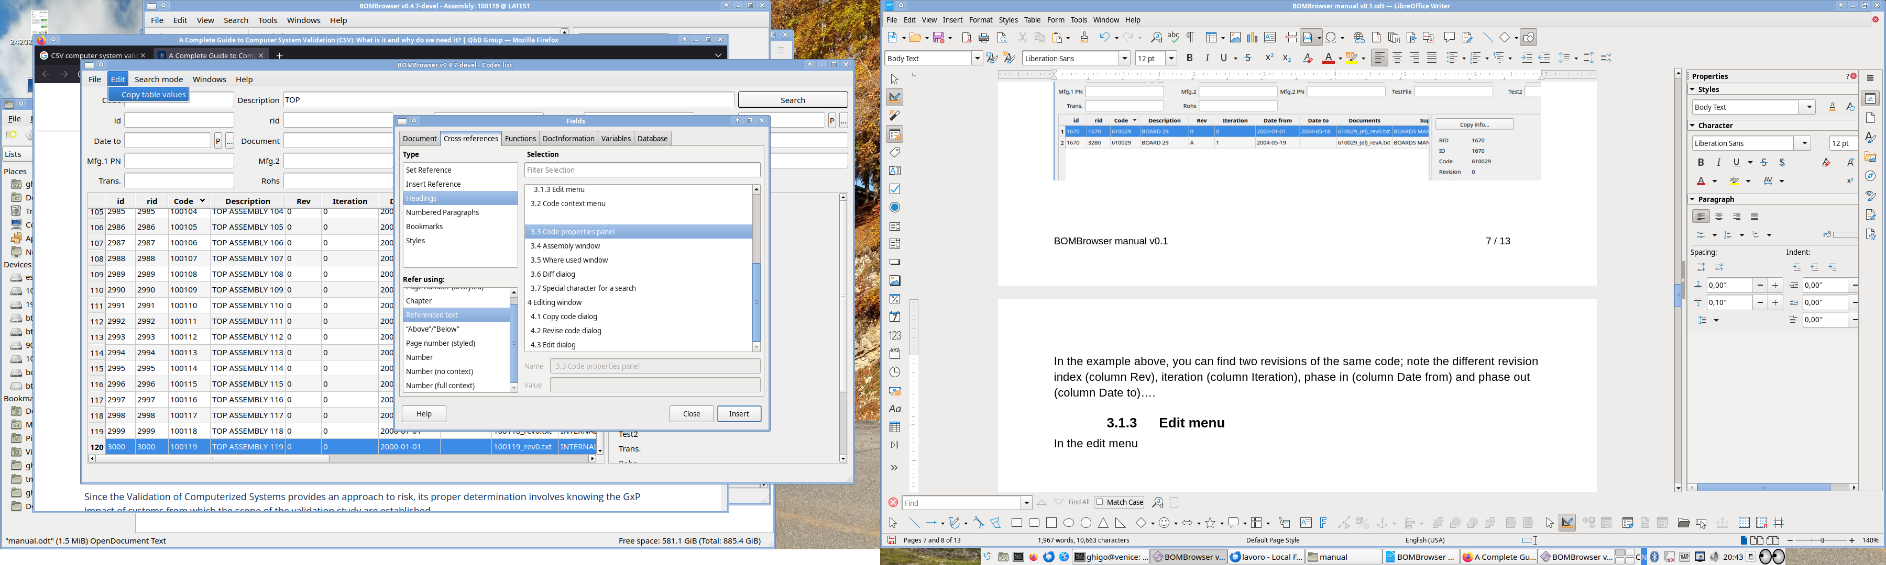

Search mode menu
The search mode menu, allows to select which search mode is active:
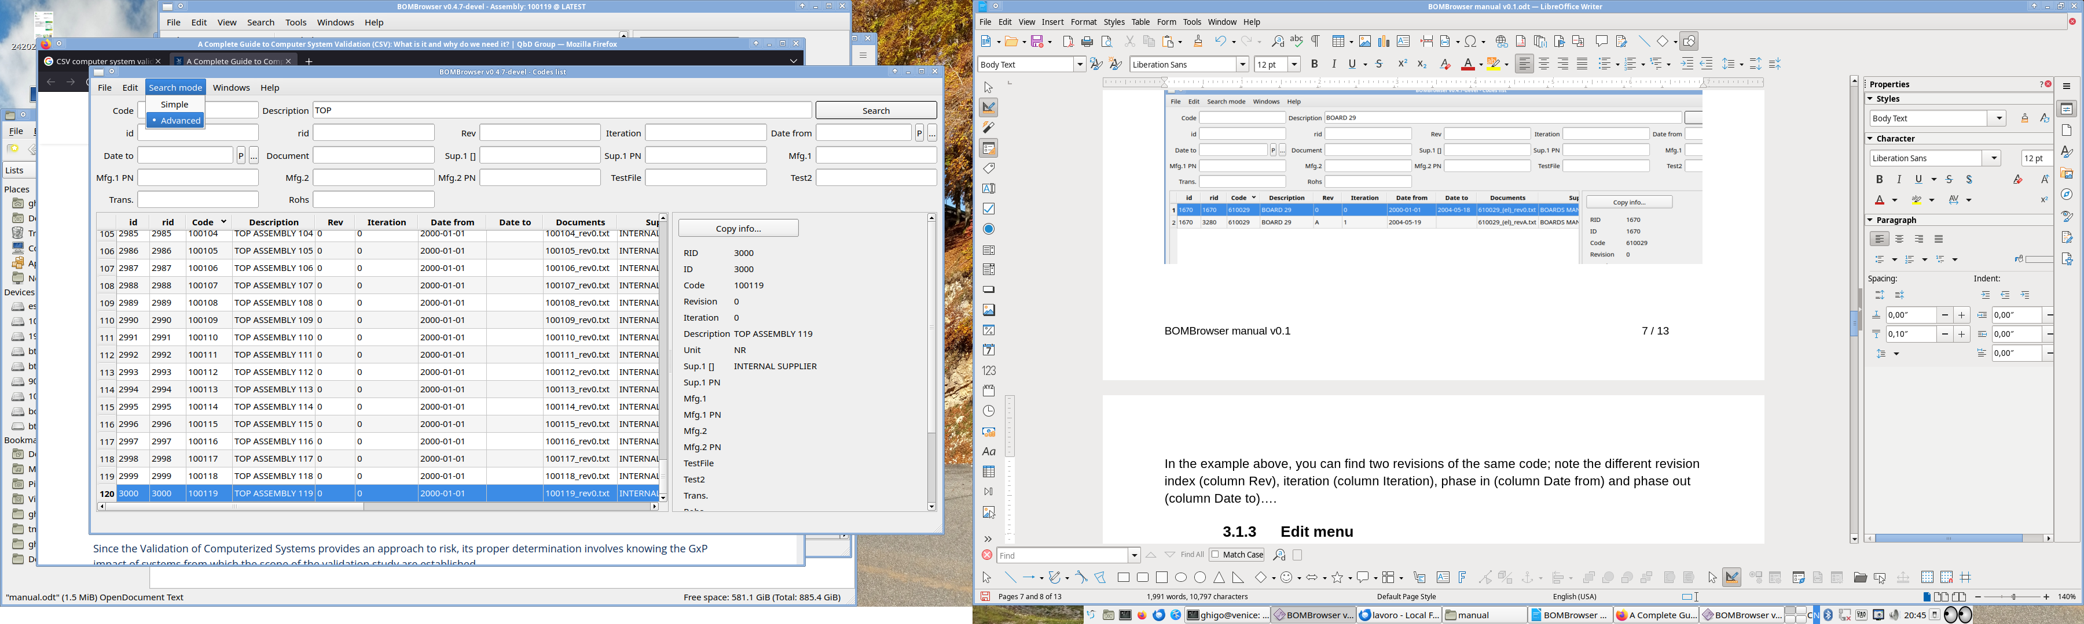
The Simple mode is the standard one, the Advanced mode is described in chapter 3.1.4 - Advanced search.

Advanced search
It is possible to access to the Advanced search mode, selecting from the menu “Search mode” → “Advanced”
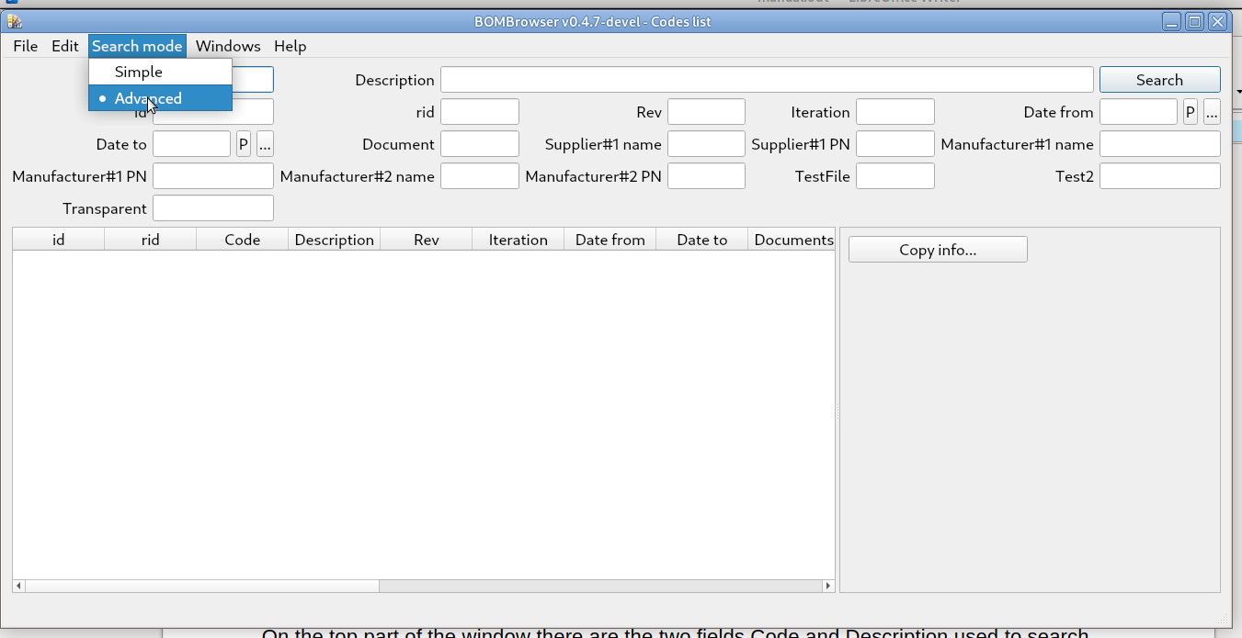
This mode allows to search not only on the basis of the code and the description, but also on the basis of any attributes. The rule is the same of the “Simple” search: the results are the ones that match ALL the filter.
One of the key differences between the Simple search and the Advanced search, is that the former returns a list of pair code + description, where the latter returns a list of the code revisions.

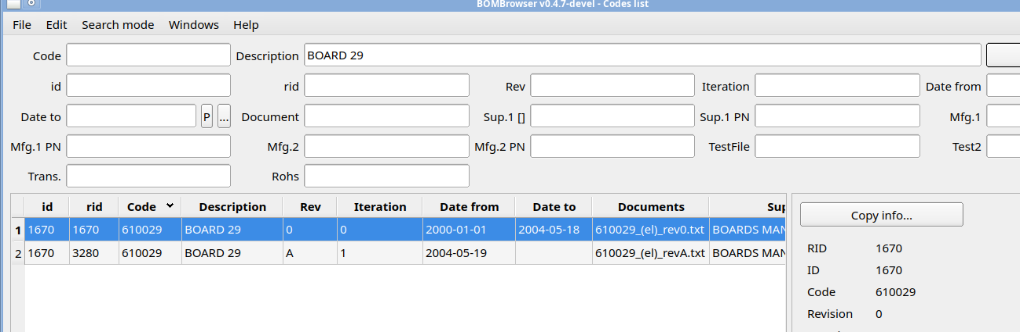
In the example above, you can see two revisions of the same code; note the different revision index (column Rev), iteration (column Iteration), "date from" (column Date from) and "date to" (column Date to)….

Code context menu
When the mouse pointer is over a line containing a code, using the right mouse button it is possible to access to the code context menu:
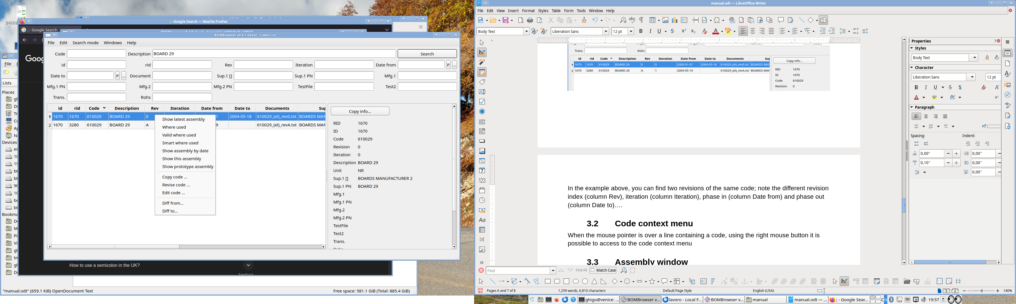
From this menu the user can access to the actions that it is possible perform on a specific code and or revision. The possible actions may change depending by the context and the possibility to change the database or not. The actions are:
- Show latest assembly
This command shows the latest assembly (not prototype) associated to a code. See chapter 3.5 - Assembly window for further information.
- Show assembly by date
This command shows a dialog box, where the user case select any of the available BOMs indexed by date. See chapter 3.5 - Assembly window for further information.
- Show this assembly
This command shows the specific BOM associated to this specific "date from" revision of the code. See chapter 3.5 - Assembly window for further information.
- Show prototype assembly
This command shows the prototype BOM associated to the code. See chapter 3.5 - Assembly window for further information.
- Where used
This command shows where (and when) a code is used. See chapter 3.6 - Where used window for further information.
- Valid where used
This command shows where (and when) a code is used. However it consider only the latest revision without a "date to". This is used to look where a component is used in the active products. See chapter 3.6 - Where used window for further information.
- Smart where used
This command shows where (and when) a code is used. However it consider only the latest revision without a "date to", and shows only the code searched, the assembly where the code is contained and the top code which represents a product. See chapter 3.6 - Where used window for further information.
- Copy code
This code is used to copy a code. See chapter 4.1 - Copy code dialog for further information.
- Revise code
This code is used to revise a code. See chapter 4.2 - Revise code dialog for further information.
- Edit code
This code is used to edit/delete code. See chapter 4.3 - Edit code dialog for further information.
- Diff from … / Diff to …
This code is used to compute the diff between two specific revision. See chapter 3.7 - Diff dialog for further information.

Code properties panel
On some windows (Assembly, Where used, Codes search) the right panel is called Code property panel.
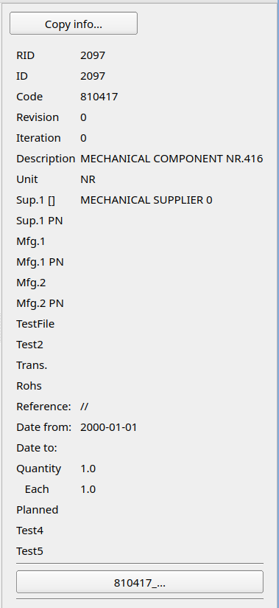
This panel shows all the metadata associated to a code. In the bottom part of this panel, there are listed the attached documents or urls to the specific revision.
Clicking with the left mouse button, on the button of a document, it is possible to open the document. Clicking with the right mouse button, it is possible to access a context menu that allow to:
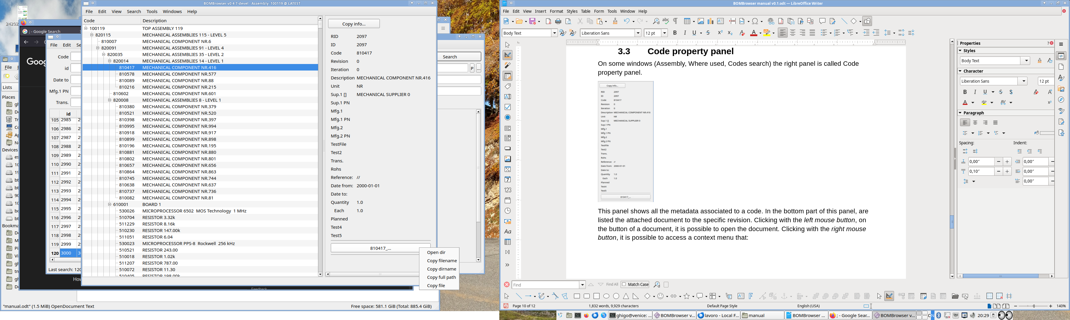
- Open dir: open the directory where the file is stored
- Copy filename: copy the filename in the clipboard
- Copy dir name: copy the directory name where the file is stored in the clipboard
- Copy full path: copy the full path of the file in the clipboard
- Copy file: copy the file in the clipboard
Clicking with the left mouse button, on the button of a URL, it is possible to open the URL (typically with a web browser). Clicking with the right mouse button, it is possible to access a context menu that allow to:
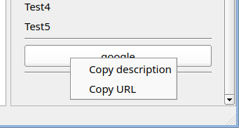

- Copy description: copy the description text in the clipboard
- Copy URL: copy the URL text in the clipboard

On the top part of the panel, there is the button “Copy info ...”
which copy on the clipboard the attributed showed in the panel.

If the panel is associated to a code, in the top left portion there is a list-box menu which permits to select the revision (indexed by date) to show.
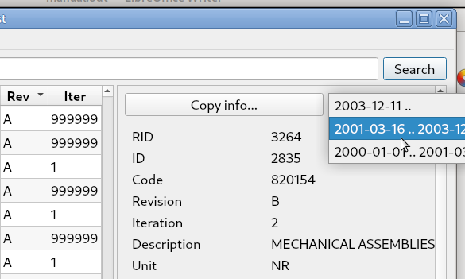

Shared windows menu
Each window has its own set of menu. However some menu are standard between the windows. In this chapter the common menus are described.

Windows menu
This is a menu present in any window. In this menu it is possible to select and bring up a window.
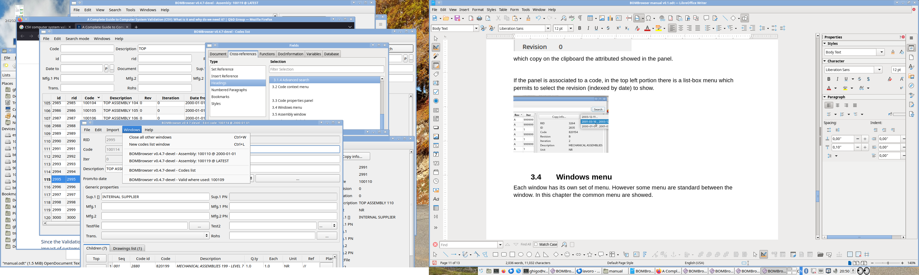
It is also possible to close all the other windows but the active one (CTRL+W), or to open a new Code list window (CTRL+L).

Help menu
With this menu
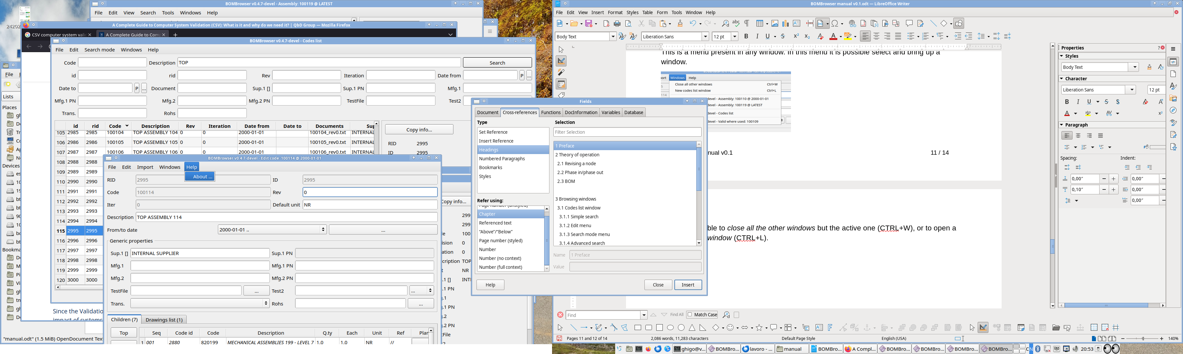
it is possible to show the about dialog.
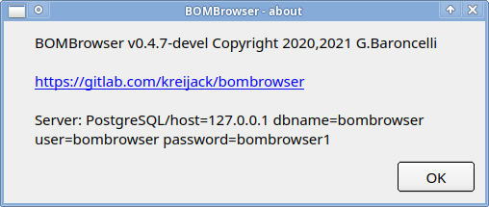

File menu
The file menu is specific for each window. However every file menu as a minimum common set of commands:
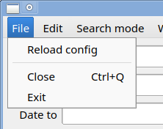
- Reload config: reload and apply the configuration file
- Close: close the current window
- Exit: exit from BOMBrowser

Assembly window
The assembly window, shows a BOM
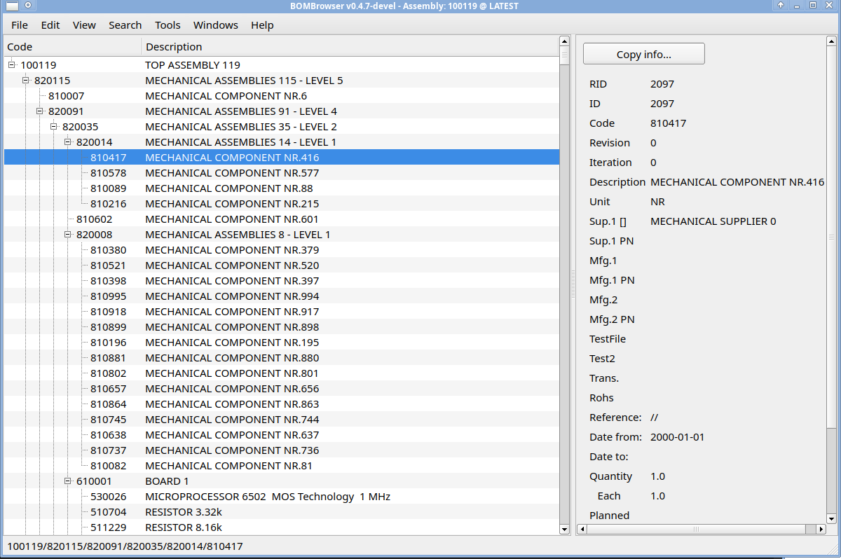
The left panel contains the tree where the user can select a specific code. On the right there is the Code properties panel which shows the code properties and the attached documents (if any). See chapter 3.3 - Code properties panel for further information.
The window title details which BOM is showed in terms of top code and date (or LATEST).

File menu
The file menu
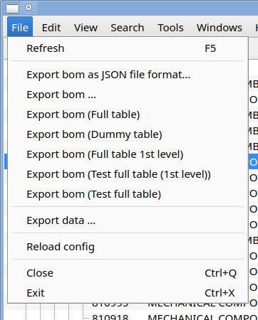
contains the following commands:
- Refresh: refresh the assembly (useful if in another window the user is editing a code)
- Export bom …: these commands export the bom showed in different formats. These format are configured in the configuration file.
- Export data…: this command starts the export dialog. See chapter 3.5.5 - Export dialog for further information.

Edit menu
The edit menu
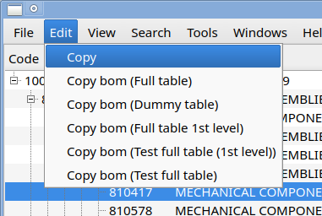
contains the Copy command, that copies the BOM to the clipboard. Different format for the BOM are available and are configured in the configuration file (see chapter 5.1 - Configuration file for further information).

View menu
The view menu
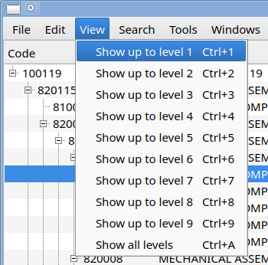
set the depth of the BOM to shows.
Selecting “Show up to level 2”, in the tree windows only the first two levels are showed. | 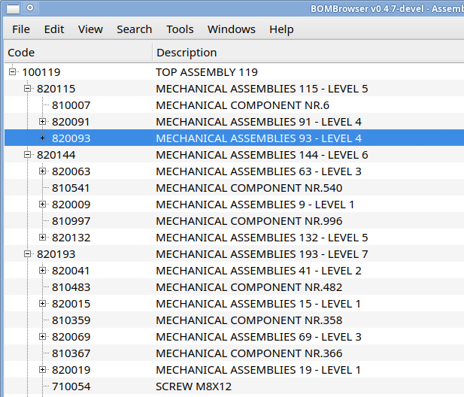
Selecting “Show all levels”, in the tree windows all the levels are showed. | 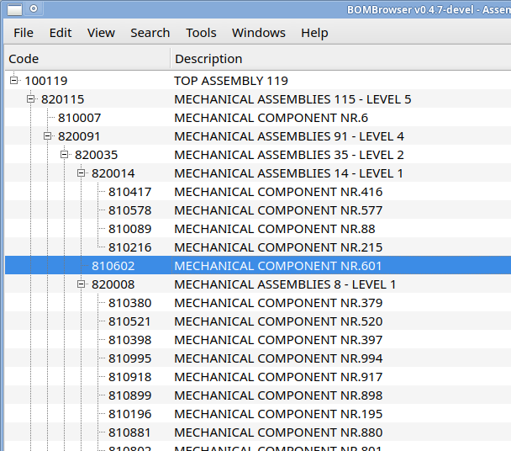

Search menu
The search menu
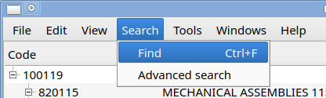
has two commands:
- Find: shows a dialog to search inside the BOM
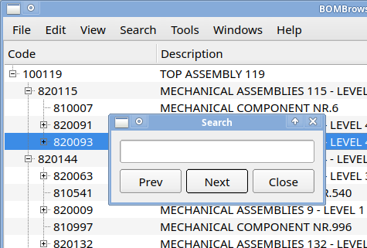
pressing prev and next it is possible to search forward and backward in the bom.
- Advanced search: open a Search in bom window, which acts like the Advanced search window but search only inside the BOM.
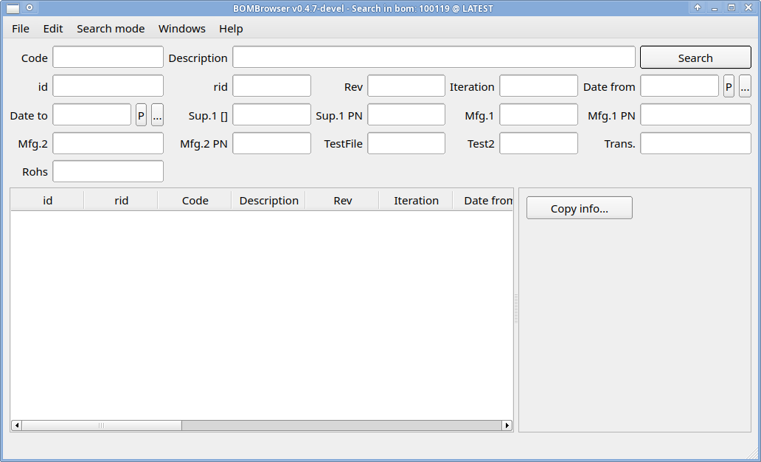

Export dialog
The export dialog
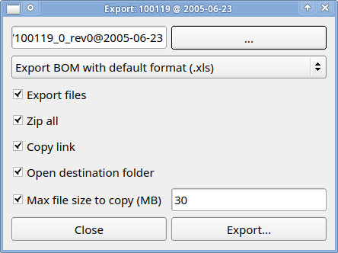
exports the BOM with all the documents attached. The “…” button allow to enter a directory where the data are stored.

This button
allows to select a different format for the BOM. This is configured in the configuration file (see chapter 5.1 - Configuration file for further information).
For the export the following options are available:
- Export files: all the files attached to the node of the BOM are exported.
- Zip all: after the export all the files are zip-ed togher.
- Copy link: the link of the directory (or the of zip file if the option is enabled), it is copied in the clipboard after the export.
- Open destination folder: after the export the destination folder is opened
- Max file to copy: allows to set a maximum file size to export (e.g. a file bigger than this limit is not exported).

Where used window
The Where used window is very similar to the assembly window. The main difference is that in the Assembly window, the BOM is showed from the TOP code to the leafs. In the Where used window, the BOM is showed starting from a leaf to all the possible TOP codes.
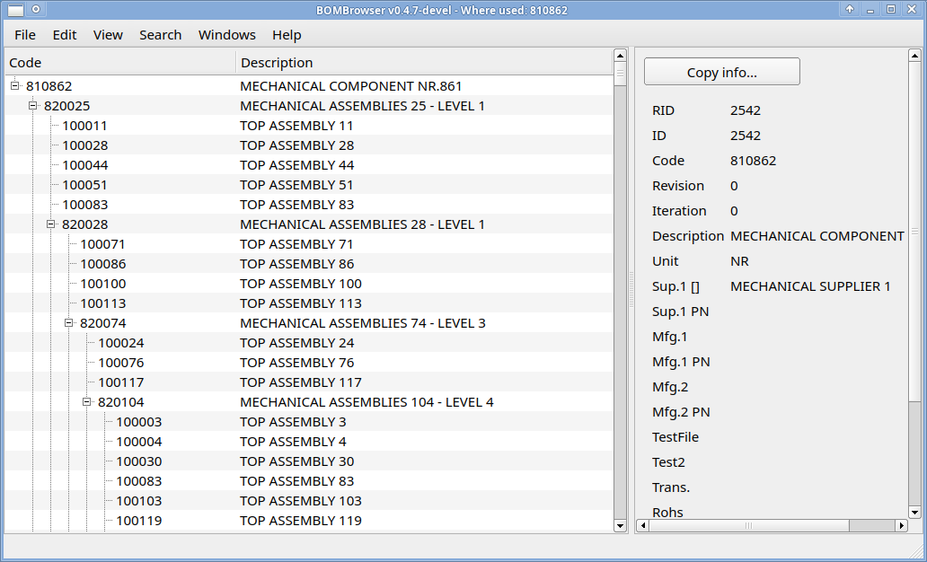

If a code is contained in two revisions of a parent code, both these revisions are showed in the tree panel.
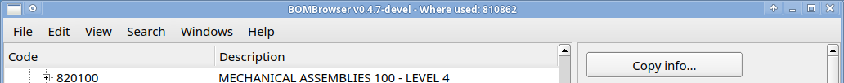
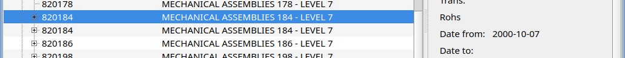
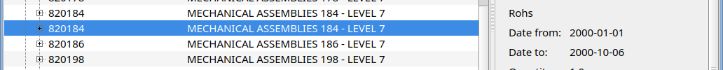

In the example above, the code 820148 compares two times, the first instance is a revision with a "date from" of 2000-10-07. The second instance, has a "date from" of 2000-01-01 and a "date to" of 2000-10-06.
The Where used windows has three different variants:
- Standard: the code is searched in all possible products
- Valid where used: the code is searched only in the valid code, i.e. the code without a "date to"
- Smart where used: the code is searched only in the valid code, and the BOM is showed partially; only the first assembly and the TOP code are showed.
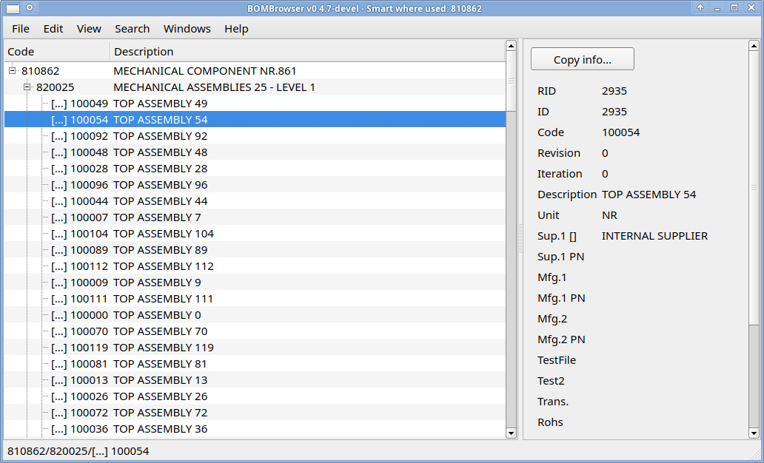

Diff dialog
The diff dialog allows to compare two BOM. In order to compare the two BOM, two different revisions have to be selected. To do that you need to starts the command “Diff from” from a code:
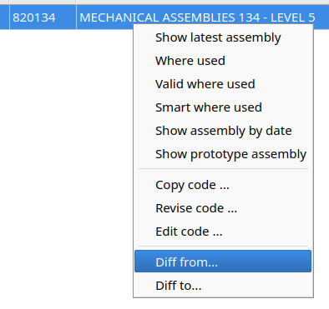
After that a dialog that allow to select a specific date will appear:
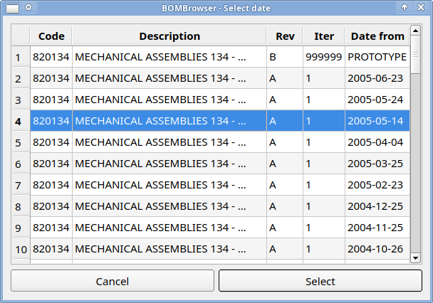
After that a date is selected, another dialog will appear
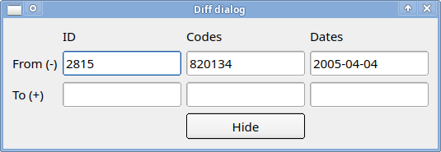
The “From (-)” row, show which BOM (identified by a code and a date) is the “starting” point for computing the difference.
After that repeat the same action with the “Diff to” command:
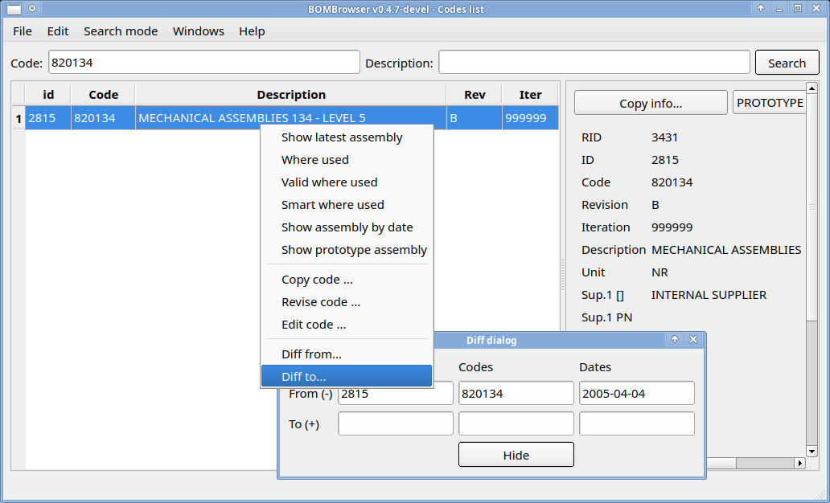

Again a dialog to select a specific date will appear, so the user can select a “target point” for computing the difference.
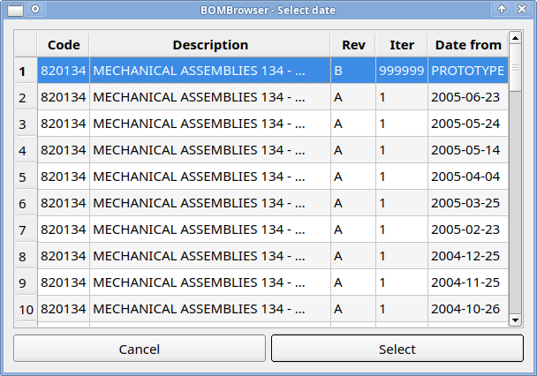
The a windows with the results will appear
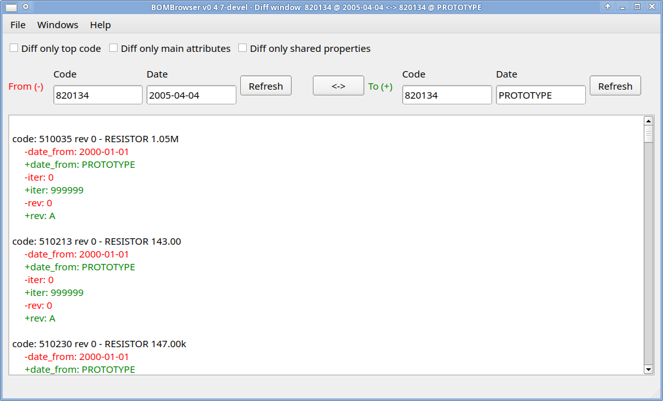
This output windows will contain the code removed (marked in red), the code added (marked in green) and the properties changed.
The idea is to describe the changes that have to applied to the BOM “from” to reach the status of the BOM “to”.
The BOMs to compare may have different TOP code. If the user starts the command Diff from/Diff to from specific revision (e.g. selecting the revision from the Search advance window, which shows only the revisions of a code), the Select date dialog will not appear and the revision will be automatically detected.

Special character for a search
Special characters may be used to make powerful query:
- ‘%’ (percent), it means any sequence of characters
- ‘_’ (underscore), it means any character (one character)
- ‘=’ (equal), it means exactly the string that follow
- ‘;’ (semicolon), it means the query before the ‘;’ OR after ‘;’

Examples:
- 123% Any sequence of characters that starts with ‘123’
- 123 Any sequence of characters that contains ‘123’
- %123 Any sequence of characters that ends with ‘123’
- 12__45 Any sequence composed by ‘12’ the any two characters then ‘45’
- 123%;456% Any sequence that starts with 123 OR starts with 456
- 123;456 Any sequence that contains 123 OR contains 456
- =678%9;987 Any sequence equal to 678%9;987
- ;= 678%9;987 Any sequence that is equal to 678%9 OR contains 987

Note: if ‘;’ is the first characters, then it is considered a separator between different set of query; if ‘=’ is the first character, then ‘;’ (or any other special character) is considered not special.

Standard code properties
Each node has a minimum set of properties:
Property name | Meaning
code | The code that represent a node. It is a constant between the revisions.
revision | The revision of the node. It is a free text.
iteration | The number of the iteration of a node. The iterations may be not consecutive (e.g. a revision might be canceled), but the revisions are ordered on the basis of the iteration.  If a new revision is generated the iteration of the new revision is equal to the iteration of the previous one + 1.
description | The description associated to a node.
unit | The measure unit of a node.
"date from" | The "date from" when the revision is valid.
"date to" | The "date to" when the revision is valid.
RID | Revision ID, an internal number that represent a specific revision.
ID | (Code) ID, an internal number that represent a specific code.

Further properties may be configured in the configuration file (see chapter 5.1 - Configuration file for further information).

Editing window

Copy code dialog
The command copy code is used to duplicate a code. This is the only mode to create a new code. In fact when an empty database is created, it contains at least one code.
When the user starts the copy code command from a code, the select date dialog will appear.
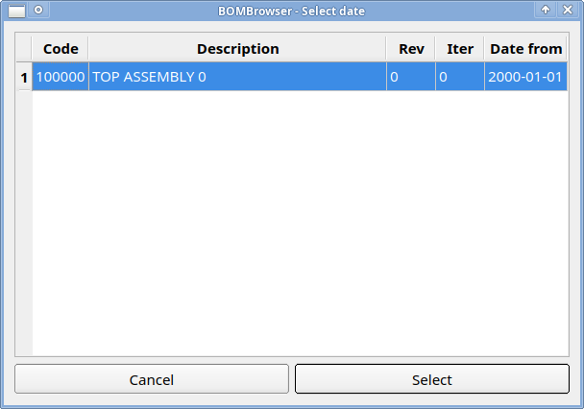
With this dialog it is possible to select a specified revision of code from which the new code will be copied. After that the following dialog will appear:
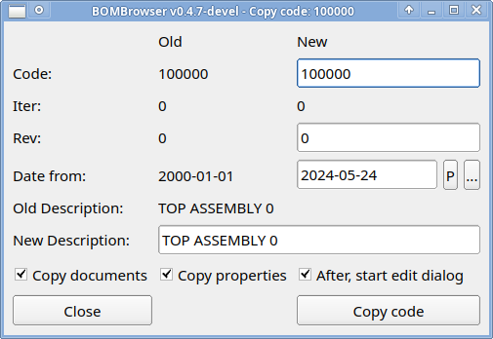
In this dialog it is possible to change:
- The new code; an error is raise if this code already exists
- The "date from" date (Phase in date)
- The initial revision
- The new description

In the lower part of the dialog there 3 check boxes:
- Copy document: if selected the link to the document will be copied too in the new code
- Copy property: if selected the properties will be copied too in the new code
- After, start edit dialog: if selected after the copy of the code the edit code dialog will appear.

Revise code dialog
The command revise code is used to make a revision of a code.
When the user starts the revise code command from a code, the select date dialog will appear.
With this dialog it is possible to select a specified revision of code from which the new revision will be copied. After that the following dialog will appear:
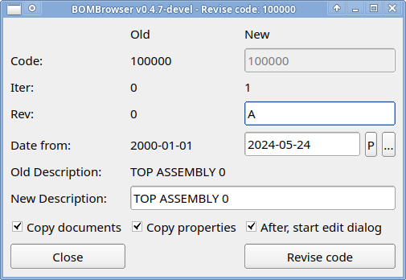
In this dialog it is possible to change:

- The "date from" date (Phase in date)
- The new revisions
- The new description

In the lower part of the dialog there 3 check boxes:
- Copy document: if selected the link to the document will be copied too in the new code
- Copy property: if selected the properties will be copied too in the new code
- After, start edit dialog: if selected after the revision of the code the edit code dialog will appear.

Edit code dialog
The edit dialog is the main interface to change a node. The possible changes are:
- change of the description
- change of the revisions
- change of the default unit
- change of the "date from" dates
- change of the children
- change of the properties (configured in the configuration file, see chapter 5.1 - Configuration file for further information).

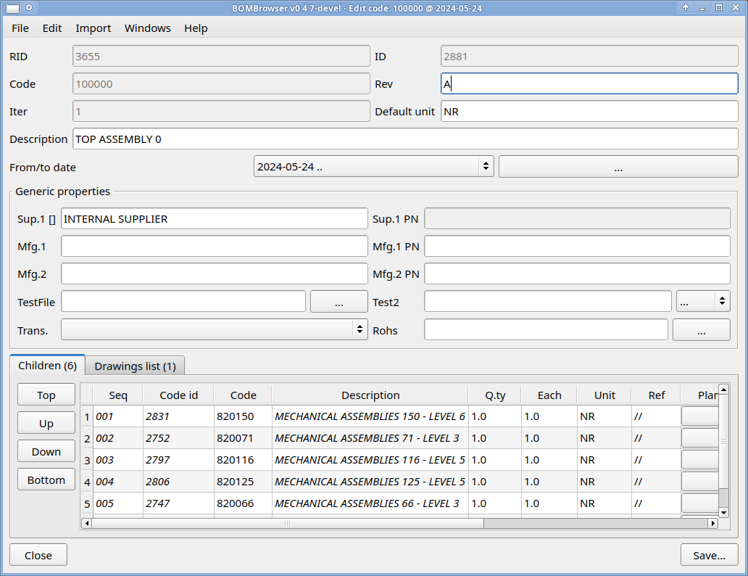
If the user exit from the form but a change was already done, a dialog will ask if the user want to save or not the data before changing the revision.
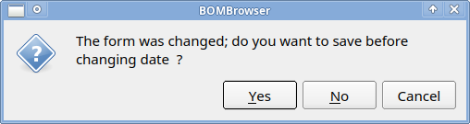

Change of the children list
In the lower part of the Edit code dialog, there is the children list.

It is possible to change the sequence of the children selecting a row(s) and pressing the buttons
- TOP: move the selected row(s) in the top position
- UP: move the selected row(s) in up by one position
- DOWN: move the selected row(s) in down by one position
- BOTTOM: move the selected row(s) in the bottom position

Pressing the right mouse button is possible to access to a context menu
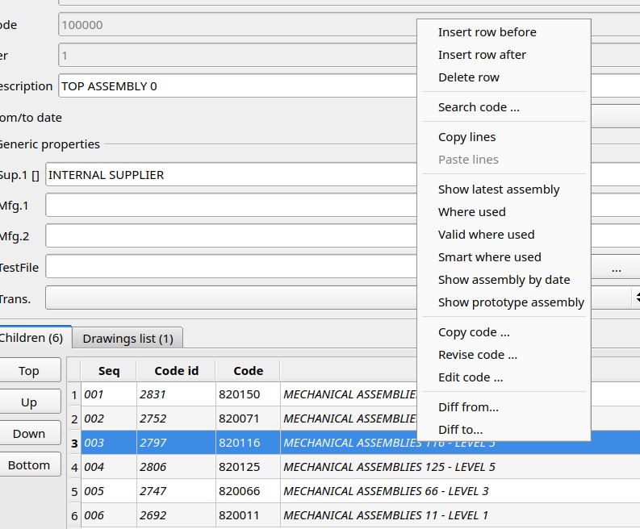
that allows to access of the standard command (See chapter 3.2 - Code context menu for further information) and some specific commands like:
- insert row before: insert an empty row before the one selected
- insert row after: insert an empty row after the one selected
- delete row: delete the selected row(s)
- search code: open a dialog that allows to change the code searching a new one
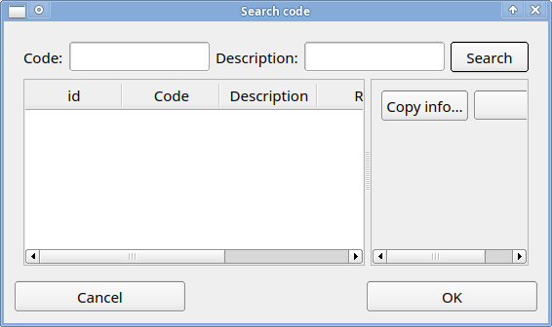
- copy lines: copy the selected lines in the BOMBrowser memory
- paste lines: paste a previously copied lines from the BOMBrowser memory

On each row it is possible to change:
- Code
- Q.ty
- Each
- Unit (by default this field is filled by the ‘default unit’ of the child code)
- Ref(ence)
- Some further fields configured in the configuration file (see chapter 5.1 - Configuration file for further information).

Change of the drawings
Selecting the Drawings list tab, it is possible to access to the attached document to the node.
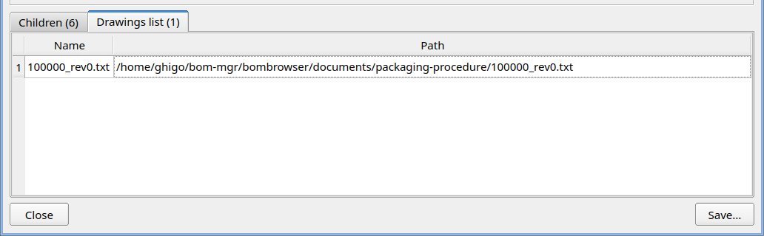
Double clicking the line, it is possible to view the document.
Pressing the right mouse button it is possible to access a context menu
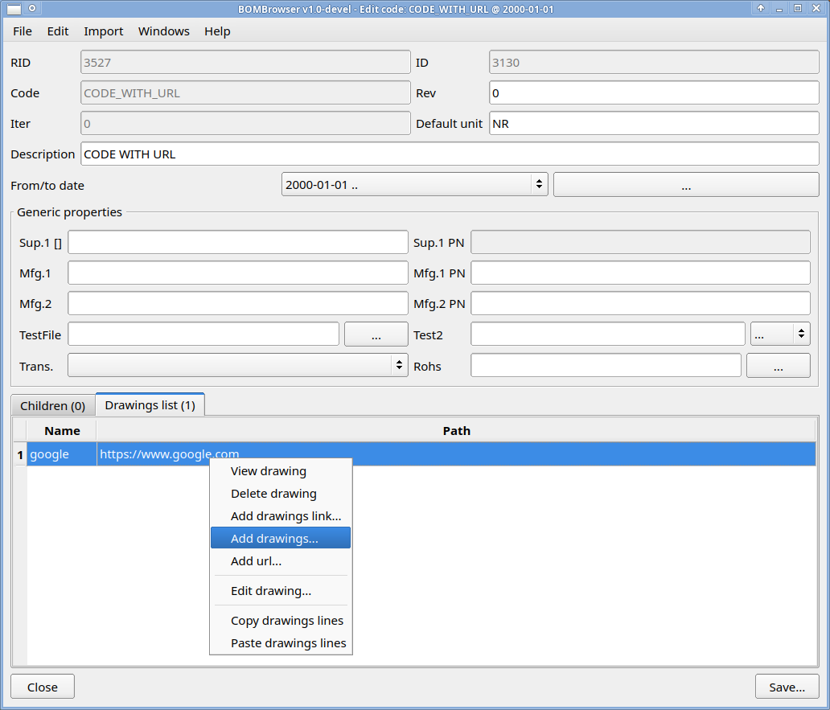
which allows:
- View drawing: view the selected document
- Delete drawing: delete the selected documents
- Add drawing link: link a new document to the node
- Add drawing: attach a new document to the node
- Add URL: attach an URL to the node
- Copy drawings lines: copy the selected line(s) into the BOMBrowser memory
- Paste drawings lines: paste a previously copied line(s) from the BOMBrowser memory

A drag and drop action, will attach a new document to the node.

Change of the "date from" dates
Using the button showed below
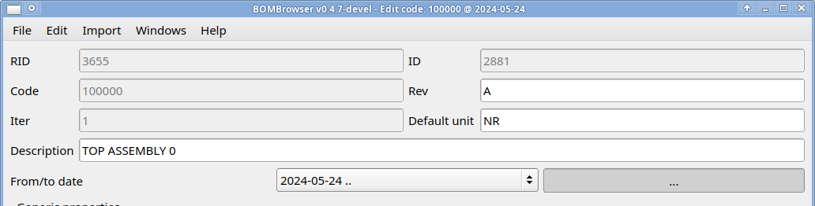
It is possible to access to a dialog which allows to change the "date from" dates of the code revisions.
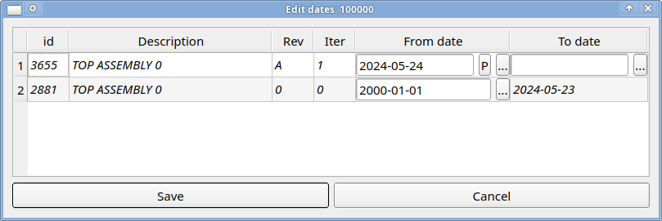

In this dialog each line represents a specific revision of which it is possible to change the "date from" date. For the latest revision it is possible to change also the "date to" date.
Pay attention that changing the first "date from" date or the latest "date to" date it is possible to break the rule that a child node must outlive the parent node. In this case the following dialog will appear when the user tries to save.:
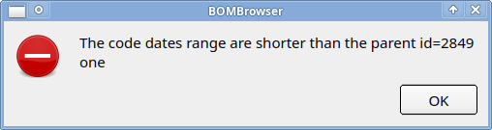
(to find the right parent, search a code with ID equal as showed in the dialog)
Another source of problem is when the "date from" date are not in the same order as the revisions. Even in this case an error dialog will appear when the user tries to save:
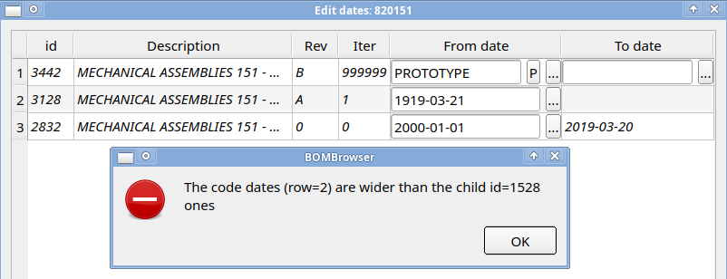

Change the revision on which the dialog is operating
Using the menu showed below
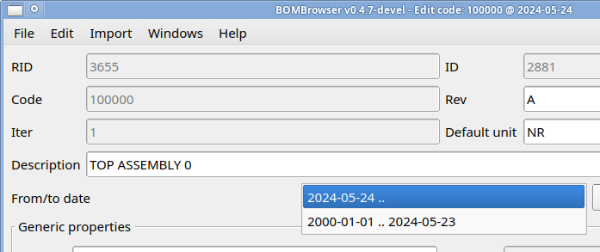
it is possible to selected a different revision of the code to change. If a change was already done, a dialog will ask if the user want to save or not the data before changing the revision.

Menu edit
The menu edit
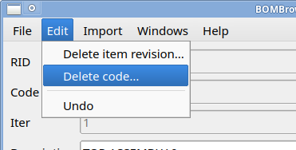
has the following commands:
- Delete item revision: remove the current selected revision
- Delete code: remove the code with all the revisions
Note: if the code is used in another assembly, it is not possible to delete a code. The user first has to remove the code from all the parents revisions.
- Undo: revert any change to the initial state

Menu import
The menu import is a custom menu (via the configuration file see chapter 5.1 - Configuration file for further information) that allows to import the data from a foreign source.
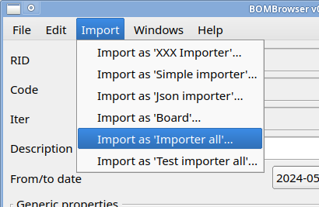

Technical details

Configuration file
When BOMBrowser starts, it reads the configuration file called bombrowser.ini stored in the same folder of the executable. This file has a classic .ini format; refer to the comment in the .ini file for the meaning of the properties.
If in the executable folder exists a file called bombrowser.forward,the content of this file is used as path to the .ini file that BOMBrowser will read.

Database structure
The database is composed by 4 main tables:
- Items
- Item_revisions
- Assemblies
- Drawings
The Items table, is a table that contains the code. Each code is unique in this table.
The Item_revision table, is a table that contains the revisions. Each revision is linked to a code in the Items table. Several revisions may refer to the same code, and in this case each one is a revision of the same code. A revision contains all the information of a node like description, units, revision text, iteration, "date from" date, "date to" date…. The revisions are ordered by iteration, and for each iteration the "date to" of an iteration n-1 is equal to the "date from" -1 of next iteration. The iteration may be not consecutive.
The Assemblies table contains the link to a specific revision and a link to its children. A child is identified by the code. The date of the BOM decides which revision of the child has to be considered.
The Drawings tables contains the link to a specific revision and a path of a document. The documents are stored in a directory (usually a shared folder). Other than a link to a document, this table may contain also an URL (http://, https://, ftp:// ).
Below a simplified definition of the tables using the SQL syntax.
CREATE TABLE items (
id INTEGER NOT NULL IDENTITY PRIMARY KEY,
code VARCHAR(255) NOT NULL
);

CREATE TABLE item_revisions (
id INTEGER NOT NULL IDENTITY PRIMARY KEY,
code_id INTEGER,
date_from_days INTEGER DEFAULT 0, -- 2000-01-01
date_to_days INTEGER DEFAULT 999999,
ver VARCHAR(10) NOT NULL,
iter INTEGER,
type VARCHAR(255),
note VARCHAR(255),
descr VARCHAR(255) NOT NULL,
default_unit VARCHAR(10) NOT NULL,

-- further properties if configured

FOREIGN KEY (code_id) REFERENCES items(id)
);

CREATE TABLE assemblies (
id INTEGER NOT NULL IDENTITY PRIMARY KEY,
unit VARCHAR(10),
child_id INTEGER,
revision_id INTEGER,
qty FLOAT,
each FLOAT DEFAULT 1.0,
ref VARCHAR(600) DEFAULT '',

-- further properties if configured

FOREIGN KEY (child_id) REFERENCES items(id),
FOREIGN KEY (revision_id) REFERENCES item_revisions(id)
);

CREATE TABLE drawings (
id INTEGER NOT NULL IDENTITY PRIMARY KEY,
code VARCHAR(255) DEFAULT '',
revision_id INTEGER,
filename VARCHAR(255) NOT NULL,
fullpath VARCHAR(255) NOT NULL,

FOREIGN KEY (revision_id) REFERENCES item_revisions(id)
);

Obviously, the relation between the tables are enforce with “foreign key”.
The fields date_from_days/date_to_days measure the date in term of day from 2000-01-01:
Date_from_days/Date_to_days | Date (YYYY-MM-DD)
0 | 2000-01-01
-100 | 1999-09-23
400 | 2001-02-04
999900 | Prototype
999999 | No date

Prototype date and “no date” are fixed values, respectably 999900 and 999999.

